
OUTI L

Exposure control: orientation diagram

by Serge BRUNEL

Exposure assessment is a process that has become more complex with the regulatory changes introduced in 2009. The layout of the file makes it essential to break down this process, which in practice is a continuous process. This diagram gives you an overview of the process, enabling you to find the right file and step for your needs.

To browse the data sheets shown in this diagram, click on the reference or enter it in the search engine.
Example: for data sheet 108, enter 22742.0108
The number after the card reference indicates the step to which you need to refer.
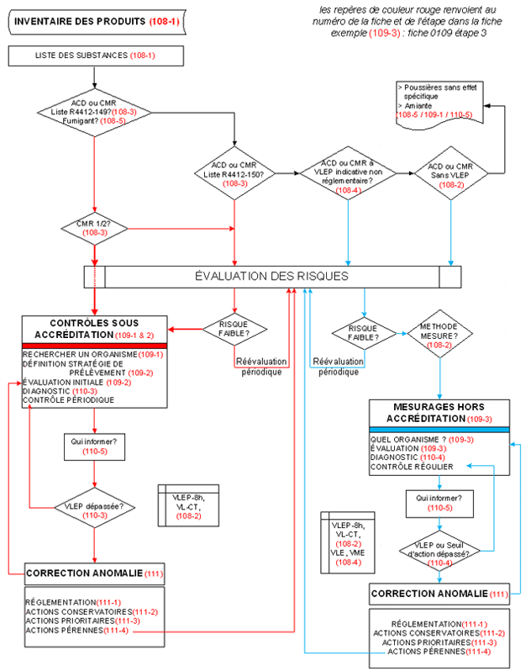
Techniques de l'Ingénieur
Techniques de l'Ingénieur

