Example of a 9-screen matrix
TOOL

by Denis CHOULIER

www.techniques-ingenieur.fr

Learn how to put the 9-screen matrix into practice with a relatively simple example: the cherry pitter.

n
Example of a 9-screen matrix applied to a cherry pitter

The product

The pitter is a small "kitchen" appliance made up of :
- A molded frame with chutes to direct the cherries upstream to the pitting area, and the "flesh" (cherry without pit) downstream to the outside.
- A support tray, which also holds the cores.
- A set of sliding parts on the frame: molded plastic handle and machined metal punch.
- A punch return spring
- A silicone elastomer tongue, positioned at the bottom of the frame, with a cross-shaped recess through which the punch can pass.
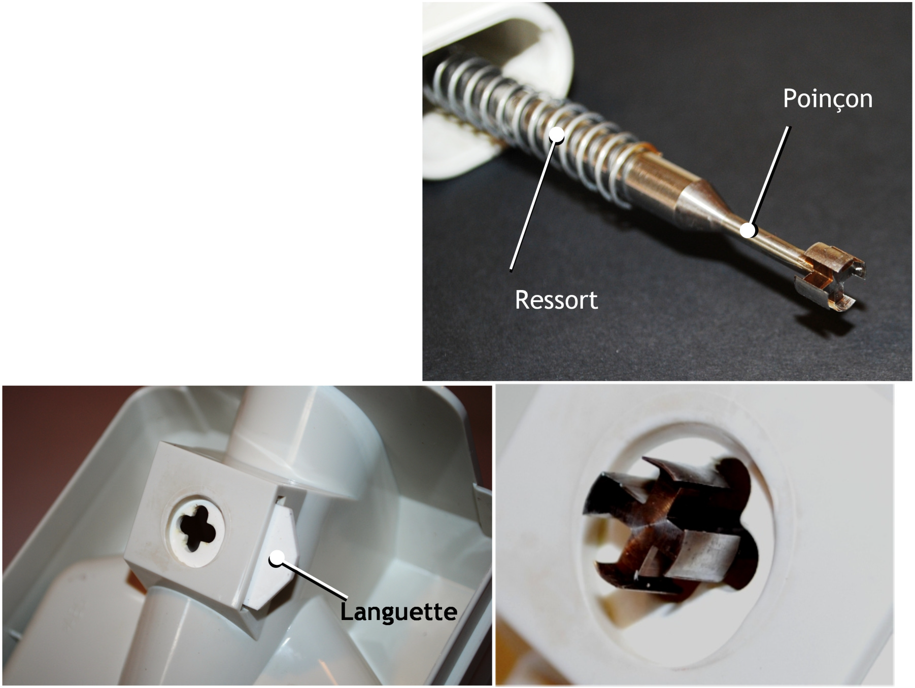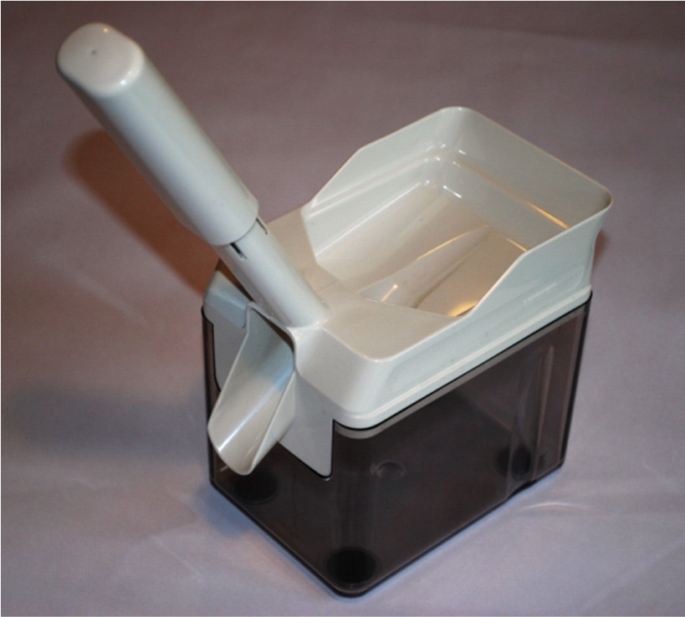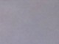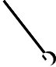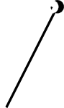
Building

Poig ée

Bin

For the operator, all he has to do is pour the cherries into the frame, guiding them roughly one by one, and then operate the handle in time.
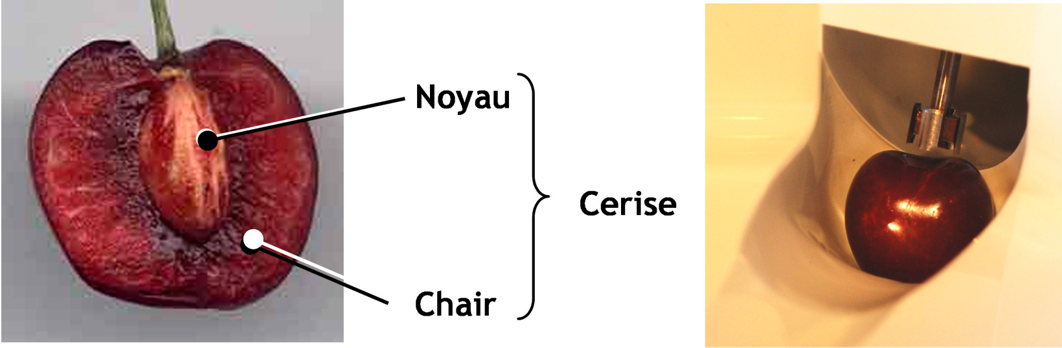

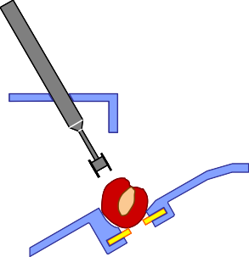Here's how it works in more detail
1
2
3
5
6
7
4

- At the start of the descent (1), the punch approaches the cherry.
- Then (2), it pierces the flesh and comes into contact with the kernel.
- It then pushes the core down (3). The lamella retains the flesh and deforms to allow the core to pass through.
- At the start of the ascent (4), the lamella retains the core, which has just detached from the flesh.
- Then (5) the punch pulls the flesh upwards, and the core falls by gravity into the tray.
- At the end of the upstroke (6), the ceiling of the frame opposes the upstroke of the meat, thus disengaging the meat from the punch.

- In the up position (7), the meat falls by gravity into the outlet chute and is discharged.

Past products
What was the cherry pitter like "before"? A product existed for the same functions in the form of an all-metal pair of pliers.
- A punch is attached to the upper arm of the pliers.
- The lower branch has a shape that welcomes and holds the cherry, and another that retains the flesh as it rises.
- There is a return spring.
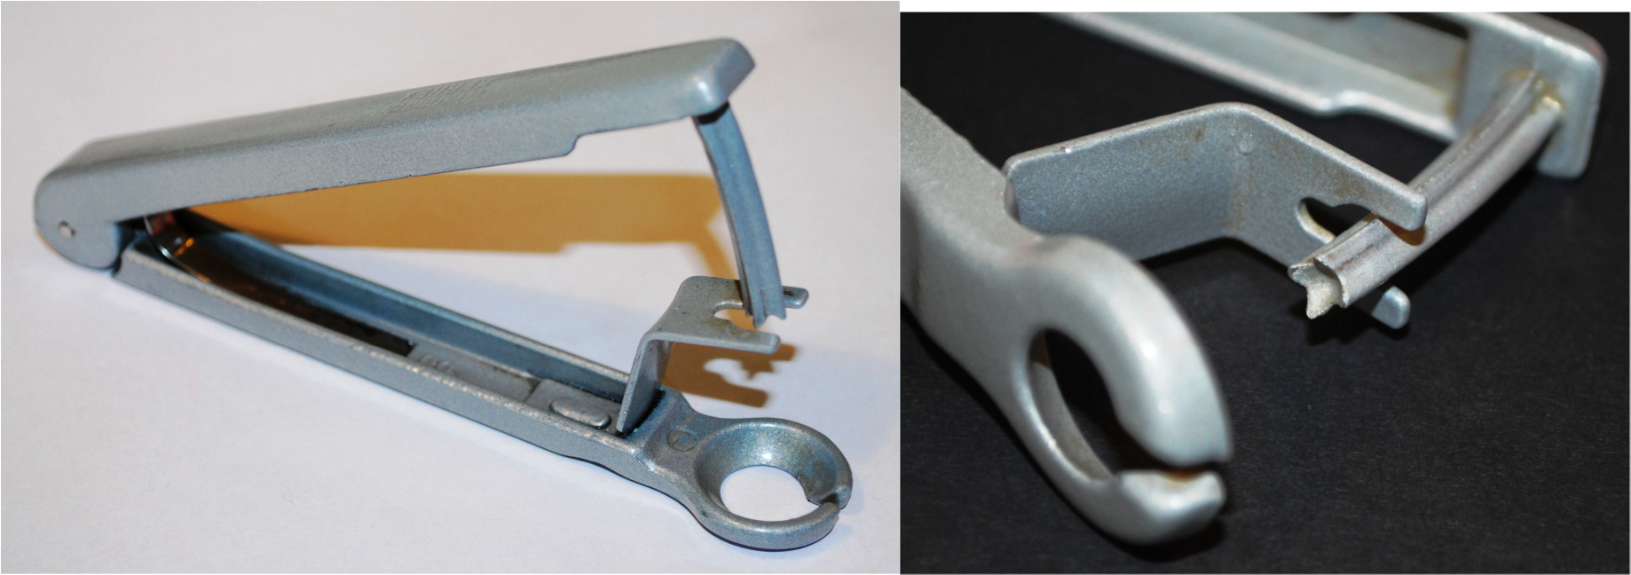
The operating principle for pitting a cherry is virtually identical, but there are some very significant differences between the two products: evolutions. Let's take a look at them and imagine the future.

The "9 screens" of the stoner
Here is a proposal for analysis and projection into the future:

Need to stone | idem | idem
Pinch" movement between palm and fingers. Finger and forearm muscles  work. | The hands hold the device. The muscles of the arms (and a little of the back)  work | Only the arm muscles work, or even other, larger muscles
The user positions each  cherry | The user "throws" the cherries,  one by one | The user throws the cherries "in  bulk"
Device "in the air": 6 DDL | On a plane (3DDL) | Fixed (0 DDL)
Several seconds per cherry | Higher cadence | Even stronger
Mark the cherry | Marque moins la cerise | No more marking the cherry
Cherry positioned in x, y, z, and  rotations | Positioned in x, y, z | Cerise will no longer be positioned
Something's pushing the core | Pushes the core, then holds it back | +, directs it, conditions it...
The flesh is no longer in contact with the device after pitting. | Chair then guided into the outlet chute | Flesh longer under system control
No spare parts. No maintenance | Changing the  wear and tear. Conditional maintenance | Other spare parts,  more frequent, systematic maintenance?
The fingers are close to the  active part | Hand away from active part | Distant hand.
Juice splashes | Juice sprayed in a confined area | No risk of splashing
Spring return | Ditto | Ditto
Short punch stroke | Longer punch stroke | Even more important
A part added to the frame holds the flesh in position  high | Part of the frame holds the meat in the raised position | An even more integrated part...
Active part obtained by intersecting a semi-spherical shape with the section  cruciform punch | More complex shapes for the active part of the punch | Even more complex.
Constant cross-section punch | Undercut at the rear of the active part of the punch (reduction)  diameter) | No more section changes
Curved hallmark | Straight punch | ???
Stamped and machined metals. | + plastic injection | Free choice of materials and  manufacturing processes.
Active part with spikes | Sharpened active part | Razor" active part
6 pieces approx. | 6 pieces approx. | 6 pieces approx.

