
Depending on the number of people in your company, you may be required to draw up a greenhouse gas emissions report. Here's what article 75 of law no. 2010-788 of July 12, 2010 says.Depending on the number of people in your company, you may be required to draw up a greenhouse gas emissions report. Here's what article 75 of law no. 2010-788 of July 12, 2010 says.
Main provisions of article 75 of law no. 2010-788 of July 12 2010

TOOL

Main provisions of article 75 of law no. 2010-788 of July 12, 2010 (Grenelle law)

Purpose: mandatory reporting of greenhouse gas emissions generated by the activities of a legal entity or local authority in France over the course of one year.

Target audience :
- Legal entities under private law employing more than 500 people (and 250 in French overseas departments and territories)
- The French State, regions, départements, metropolises, urban communities, conurbation communities and communes or communities of communes with more than 50,000 inhabitants, as well as other legal entities governed by public law and employing more than 250 people.
- Note 1: foreign subsidiaries of a French group are not concerned. On the other hand, a foreign group with a subsidiary located in France will have to carry out a greenhouse gas assessment for this subsidiary (scope of the subsidiary's activities carried out in France).
- Note 2: to determine whether or not you are concerned, the workforce to be counted is that of all your establishments registered under the same SIREN.

Methodology: This review must cover :
-Direct emissions, produced by fixed and mobile sources owned by the legal entity (inspired by scope 1 of ISO 14 064).
-Indirect emissions associated with the consumption of electricity, heat or steam required for the legal entity's activities (inspired by scope 2 of ISO 14 064).
Indirect emissions - Scope 2 - (mandatory)
- Indirect emissions linked to electricity consumption (production, transport, distribution...)
- Indirect emissions from the consumption of steam, heat or refrigeration
Indirect emissions - Scope 3 - (recommended)
- Energy-related emissions not included in scopes 1 and 2 (Extraction, production and transport of fuels consumed by the legal entity)
- Purchases of products or services
- Fixed assets
- Waste
- Inbound and outbound freight
- Business travel (with vehicles not controlled by the legal entity)
- Commuting to work
- Visitor and customer transport
- Use of products sold
- End-of-life of products sold
- Franchises, upstream/downstream leasing assets
- Other indirect emissions
Direct emissions - Scope 1 - (mandatory)
- Combustion of energy from stationary sources (boilers, furnaces, burners)
- Combustion of fuel from vehicles and machinery controlled by the legal entity
- Non-combustion-related industrial processes (decarbonation, chemical reaction, etc.)
- Refrigerant leaks
- Emissions linked to livestock, nitrogen fertilization, treatment of organic waste...
- Emissions from biomass (soil and forests)

Note: Accounting for other indirect emissions (inspired by ISO 14 064 Scope 3) is not mandatory, but recommended.
Techniques de l'Ingénieur

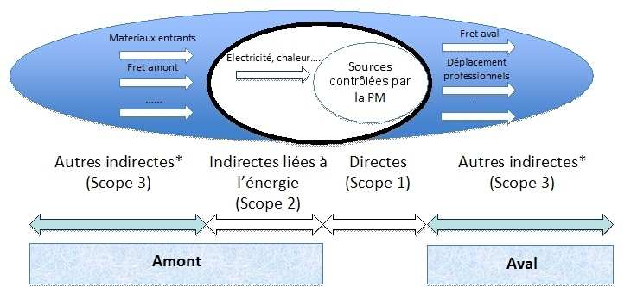

* emission items not covered by the regulatory obligation (but which may be included in the balance sheet on an optional basis)

Diagram of the different sources of emissions linked to an organization's activities ⁽¹⁾

(1) Source: "Méthode pour la réalisation des bilans d'émissions de Gaz à effet de Serre conformément à l'article 75 de la loi n°2010-788 du 12 juillet 2010 portant engagement national pour l'environnement (ENE)" - Version 2 - MEDDTL

Accounting scope
- The legal entity must account for the GHGs of all the establishments identified under its SIREN number over which it has control.
-There are 2 types of control: financial and operational.

- If the company owns and operates all its assets and activities: operational control = financial control
- If the company leases part of its assets and activities: operational control > financial control

The company defines its scope according to one or other of these controls.
Note: if a company owns or controls all or part of another company, located on national territory, with a different legal personality, the parent company may consolidate these emissions using the approach it has chosen.

Rendering: This report is...
- accompanied by a summary of planned actions;
-To be declared to the regional prefecture by December 31, 2012;
-to be updated at least every three years;
- made public.

In each region, the regional prefect and the president of the regional council are responsible for coordinating data collection, taking stock of the situation and checking the consistency of the reports.

Source: decree implementing article 75 of law no. 2010-788 of July 12, 2010 on the national commitment to the environment.
Techniques de l'Ingénieur
Techniques de l'Ingénieur

