

TOOL

Structuring with a mind map

par Jean-Pierre PAYRE

www.techniques-ingenieur.fr

Representation by means of a mind map enables you to structure your thoughts and ideas, so that you can then propose an effective and convincing representation.

www.techniques-ingenieur.fr

STRUCTURING WITH A MIND MAP

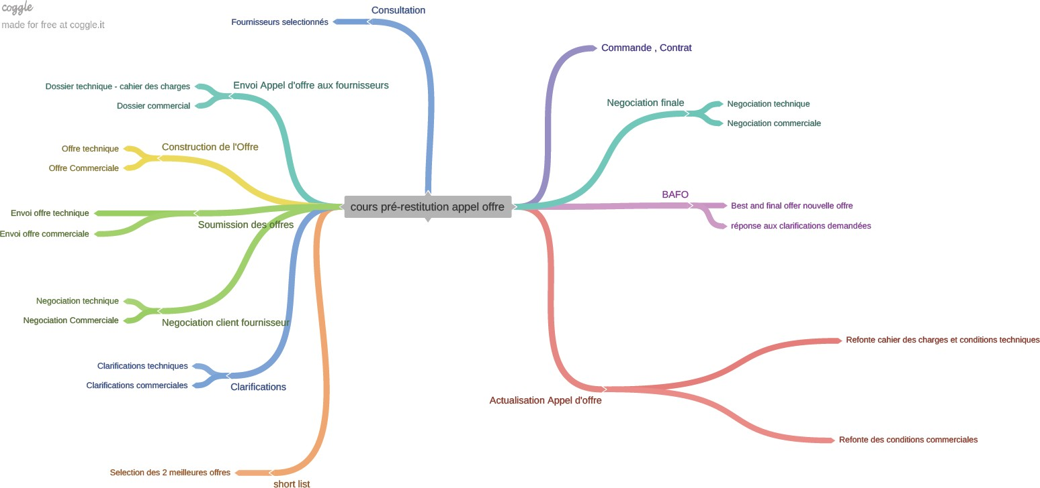

Tendering mechanism

© Engineering Techniques
Jean-Pierre Payre 2022 © Copyright
Dossier pratique |
1

