
TOOL

Variance and performance indicators and forecast calculation

by Jean-Pierre Payre

This tool uses tables to list variance and performance indicators, and provides formulas for calculating forecasts.



VARIANCE AND PERFORMANCE INDICATORS AND FORECAST CALCULATION
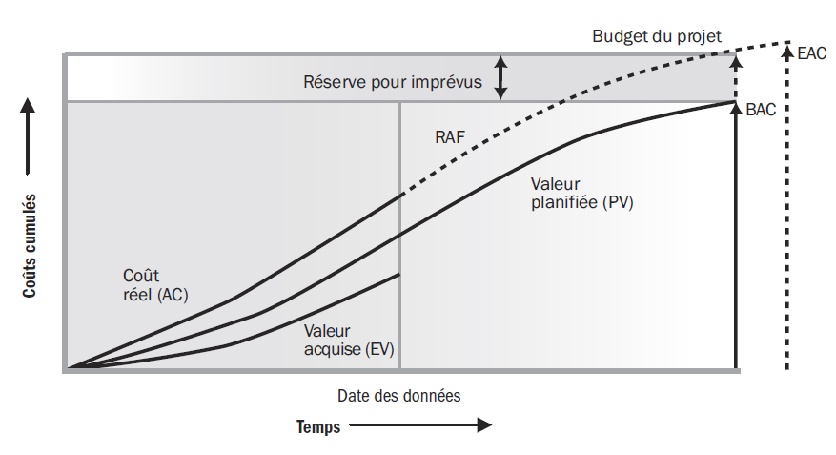

Earned value analysis key values
Acronyms | Indicators | Interpretation
VP  (PV) | Planned value  (Planned Value) | What is the estimated value of the planned work?
VA  (EV) | Earned value  (Earned Value) | What is the estimated value of the work actually done?
CR  (AC) | Actual cost  (Actual Cost) | How much does the work actually cost?

Earned value indicators
Techniques de l'Ingénieur
Acronyms | Indicators | Interpretation
PV | Planned value | Estimated value of planned work
EV | Earned value | Estimated value of work performed
AC | Actual costs | Actual cost (incurred) of work performed
BAC | Final budget | Budget for the entire project
EAC | Estimate on completion | Project cost on completion
ETC (RAF) | What remains to be done | Budget required to complete the project
VAC | Variances at end of period | Variance at end of project (over or under budget)

Variance and performance indicators "to date
Indicator | Formula | Interpretation
Cost variance  (Cost variance, CV) | = Earned value - Actual cost  = EV - AC | Negative if the project is over budget; positive if it is under budget.
Delay variance  (Schedule variance, SV) | = Earned value - Planned value  = EV - PV | Negative if the project is behind schedule - positive if it is ahead of schedule
Delay performance index  (Schedule performance index, SPI) | = Earned value - planned value  = EV/PV | This indicator is also an "end-of-project" indicator.  Progress at x% of initial forecasts
Cost performance index  (Cost performance index, CPI) | = Earned value/Actual cost  = EV/AC | This indicator is also an "end-of-project" indicator.  For each € invested, I earn € xx

The basic values of performance forecasting
Indicator | English | Abbreviation | Interpretation
Overall budget | Budget At Completion | BAC | Project budget
Estimated budget to complete the project ("reste à faire") | Estimate To Complete | EAC | Estimated additional cost to complete work from reference date

Forecast calculations for project variants
Techniques de l'Ingénieur
Terms | Formulas to remember | Calculation of the final cost of the project, based on the project's status "to date".
Overall cost estimate (Estimate At Completion)
Variant 1 | EAC = BAC/CPI | Used when the overall budget remains valid (as well as the cost performance index)
Variant 2 | EAC = AC + ETC | Used when the initial budget is no longer valid
Variant 3 | EAC = AC + BAC - EV | Used when the project budget is considered atypical for the future
Variant 4 | EAC = AC + (BAC-EV)/CPI | Used when the project budget is considered atypical for the future
Estimated remaining work  (Estimate To Complete) | ETC = BAC - AC | Additional project costs
Cost-to-completion variances  (Variance At Completion) | VAC = BAC - EAC | Evaluation of variance from initial project budget

Techniques de l'Ingénieur
Techniques de l'Ingénieur

