
TOOL

Example of an OT graphic representation

by Jean-Pierre Payre

This tool provides an example of how a TO is structured.

Example of an OT graphic representation

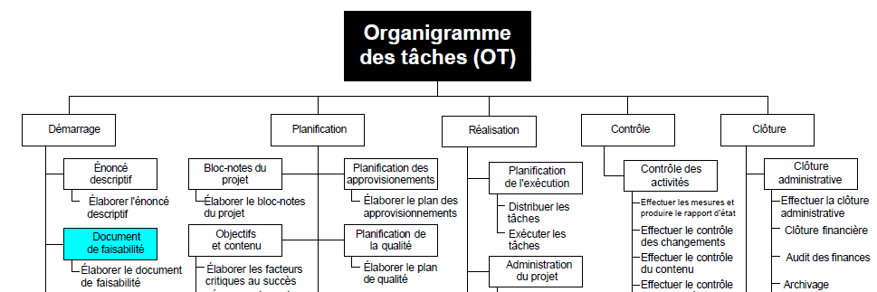
Techniques de l'Ingénieur

