
TOOL

Basic BPMN elements

by Olec KOVALEVSKY

This document provides the main elements of BPM modeling, which are essential in any business process modeling.



key BPMN elements

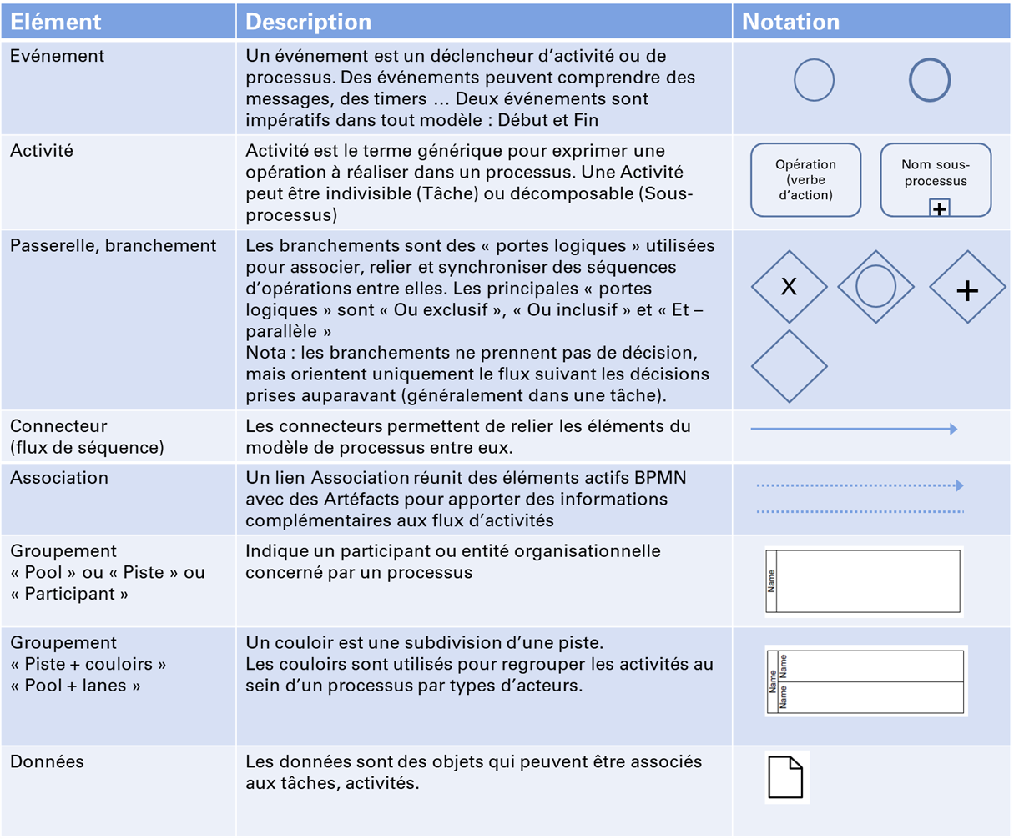

Techniques de l'Ingénieur
Techniques de l'Ingénieur

